**THE EVENT MANAGEMENT SYSTEM**

A project submitted to

**UKA TARSADIA UNIVERSITY**

in partial fulfilment of the requirements for the degree of

**Bachelor of Science**

in

**Information Technology**

for

**5 Years Integrated M.Sc.(IT)**

By

**SHIVAM PATEL**

(202006100110030)

**HARSH GANDHI**

(202006100110057)

Guided by

**MS. KAJAL PATIL**

**Assistant Professor**



**Babu Madhav Institute of Information Technology**

**Uka Tarsadia University**

**Bardoli – 394350**

**December 2022**

**CERTIFICATE**

This is to certify that **Shivam Patel(202006100110030) and Harsh Gandhi(202006100110057)** has submitted project entitled **“THE EVENT MANAGEMENT SYSTEM”** as the partial fulfillment for the award of the degree of Bachelor of Science in Information Technology for 5 Years Integrated M.Sc.(IT) in 2020 – 2021.

**Date:**

**Place:**

1. **Ms. Kajal Patil Dr. Jitendra** Guide **Nasriwala**
2. Programme Coordinator

**External Examiner**



**Babu Madhav Institute of Information Technology,**

**Uka Tarsadia University,**

**Bardoli – 394350**

**Table of Content**

|  |  |  |  |  |
| --- | --- | --- | --- | --- |
| **Chapters** | **Particulars** | | | **Page no.** |
| **1** | **Introduction** | | |  |
| 1.1 | Problem Definition | | 6 |
| 1.2 | Project Objective | | 6 |
| 1.3 | Product Scope | | 6 |
| 1.4 | Initial Requirement Document | | 7 |
|  | | | | |
| **2** | **Overall Description** | | |  |
| 2.1 | Product Perspective/ Environment Description | |  |
|  | 2.1.1 | Hardware Interface/ Hardware Specification | 9 |
|  | 2.1.2 | Software Interface/ Software Specification | 9 |
|  | | | | |
| **3** | **System Specific Requirements** | | |  |
| 3.1 | Functional Requirement | | 10 |
| 3.2 | Non-functional Requirement | | 12 |
|  | | | | |
| **4** | **System Design** | | |  |
| 4.1 | Database Design | |  |
| 4.1.1 | Database Schema | 13 |
| 4.1.2 | Data Dictionary | 14 |
|  | | | | |
| **5** | **System Analysis** | | |  |
| 5.1 | Use case Diagram | | 23 |
| 5.2 | Activity Diagram | | 24 |
| 5.3 | Sequence Diagram | | 29 |
|  | | | | |
| **6** | **System Implementation** | | |  |
| 6.1 | Screenshots | | 30 |
|  | | | | |
| **7** | **Testing** | | |  |
| 7.1 | Test Cases | | 44 |
|  | | | | |
| **8** | **Future Enhancement** | | | 46 |
|  |  | | |  |
|  | **Conclusion** | | | 46 |
|  |  | | |  |
|  | **Bibliography** | | | 46 |

**List of Figures**

|  |  |  |
| --- | --- | --- |
| **Figure no.** | **Figure Description** | **Page no.** |
| **5.1.1** | **Use Case Diagram** | 23 |
| **5.2.1** | **Activity Diagram for Registration** | 24 |
| **5.2.2** | **Activity Diagram for Login** | 25 |
| **5.2.3** | **Activity Diagram for Book Event** | 26 |
| **5.2.4** | **Activity Diagram for Cancel Event** | 27 |
| **5.2.5** | **Activity Diagram for Feedback** | 28 |
| **5.3.1** | **Sequence Diagram for “Registration”** | 29 |
| **5.3.2** | **Sequence Diagram for “Book Event”** | 30 |
| **5.3.3** | **Sequence Diagram for “Cancel Event”** | 31 |

**List of Tables**

|  |  |  |
| --- | --- | --- |
| **Table no.** | **Table Description** | **Page no.** |
|  | Data Dictionary Tables | 14 - 22 |
| 7.1.1 | Test Cases for Registration | 44 |
| 7.1.2 | Test Cases for Login | 45 |
| 7.1.3 | Test Cases for Change Password | 45 |

**Introduction**

* 1. **Problem Definition:**
* Nowadays people are celebrating every function very gracefully and for that they are facing very difficulties like finding place for function, reservation of caterers etc. To overcome this problem, we are providing platform where customer can book everything at one place from given packages.
  1. **Project Objective:**
* Events are not just about execution but a lot of other behind the scene tasks which you might never have thought of. Our expertise will let you enjoy the event without even breaking a sweat! In The Event Management System, customer can login/register into the system where he/she can book the events according to his/her convenience. Customer also can select his/her own venue. The system will also provide packages according to the customer’s budget. At the dealer side the dealers can register themselves into the system and according to the customer’s package they will get their orders. Customer can cancel the event before minimum 7 days. Customers can also give their suggestions by giving Feedback. If the dealer selected by the customer is not available then system will provide another best option.
  1. **Product Scope:**
* This system is limited to be used by stake holders of the system and bounded to be used only in **Surat** city.
  1. **Initial Requirement Document:**

|  |  |
| --- | --- |
| Title of the project | Event Management System |
| Stakeholder involved in capturing requirement | Admin, Employee, customer |
| Techniques used for capturing requirement | Brainstorming, observation |
| Name of the person along with designation | _ |
| Date | July, 2022 |
| Version | 1.0 |
| Consolidated list of Initial Document:     * A System is to be implemented which can manage the events in to the scope within Surat city. * There are three types of users in the system: Admin, Dealer (Caterer, Banquet Hall Manager, Beautyparlor, DJ operator, Decorator, photographer), Customer. * The system shall be able to generate login ID and Password to the system operator. * The System operator shall be able to manage their profile. * The system operator shall be able to change their password. * The System operator shall be able to change password in case they forget password. * Admin shall be able to manage all event as well as its category. * Admin shall be able to manage details of all members of the system. * Admin shall be able to add packages into the system. * Dealer shall be able to provide facility to the customer according to their choice. * Dealer shall be able to give feedback. * Dealer shall be able to view his/her event history. * Customer shall be able to manage their booking. * Customer shall be able to select package provided by the system according to their budget. * Customer shall be able to give feedback. * Customer shall be able to cancel the event (must be before 7 days). * Customer shall be able to view his/her event history. * The system should be able to mail the Customer/Dealer. * The system should be able to generate OTP while registering. * System will provide various ways to pay.   + UPI   + Online banking   + Credit/ debit card   + Pay on visit | |

**Overall Description**

**Product Perspective/ Environment Description**

* 1. **Hardware Interface/ Hardware Specification:**

|  |  |
| --- | --- |
| **Device Name** | LAPTOP-3EOPK9E3 |
| **Processor** | Intel(R) Core (TM) i3-7020U CPU @ 2.30GHz 2.30 GHz |
| **Installed RAM** | 8.00 GB |
| **System Type** | 64-bit operating system, x64-based processor |
| **Hard Disk** | 1 TB |

* 1. **Software Interface/ Software Specification:**

|  |  |
| --- | --- |
| **Operating System** | Microsoft windows 10 / 11 |
| **Front end** | HTML, CSS, JS, BOOTSTRAP |
| **Back end** | MySql, php |
| **Input device** | Keyboard, Mouse |
| **Output device** | Monitor |
| **Software used** | Visual studio, IDE |
| **Tools** | Xampp |

**System Specific Requirements**

**3.1 Functional Requirements:**

* User Authentication

|  |  |  |
| --- | --- | --- |
| **RN** | **Description** | **Comment** |
| **FR 1** | System shall allow users to login. | Login |
| **FR 2** | System shall allow users to logout. | Logout |
| **FR 3** | System shall allow users to change their passwords if they forget their password. | Forget Password |
| **FR 4** | System shall allow users to registration. | Registration |

* Manage user profile

|  |  |  |
| --- | --- | --- |
| **RN** | **Description** | **Comment** |
| **FR 1** | System shall allow users to view their profile. | View Profile |
| **FR 2** | System shall allow users to change their profile details. | Change Profile |
| **FR 3** | System shall allow users to change their passwords. | Change Password |

* Manage packages

|  |  |  |
| --- | --- | --- |
| **RN** | **Description** | **Comment** |
| **FR 1** | System shall allow customers to select package according to their budget. | Select Package |
| **FR 2** | System shall allow customers to view package. | View Package |
| **FR 3** | System shall allow admin to change package details. | ModifyPackage |

* Manage events

|  |  |  |
| --- | --- | --- |
| **RN** | **Description** | **Comment** |
| **FR 1** | System shall allow customers to select events according to their choices. | Select event |
| **FR 2** | System shall allow customers to view events. | View event |
| **FR 3** | System shall allow admin to change event details. | Modify event |
| **FR 4** | System shall allow customers to cancel booked events. | Cancel event |

* Feedback

|  |  |  |
| --- | --- | --- |
| **RN** | **Description** | **Comment** |
| **FR 1** | System shall allow admin to view feedbacks given by customers. | View Feedback |
| **FR 2** | System shall allow customers to give feedback. | Give Feedback |

* Manage payments

|  |  |  |
| --- | --- | --- |
| **RN** | **Description** | **Comment** |
| **FR 1** | System shall allow customers to make payment. | Make Payment |

**3.2 Non-Functional Requirements:**

* Confidentiality
* System shall allow only users to see their profile.
* Integrity
* System shall not allow any other user to change information.
* Availability
* System shall allow users to access their information anytime.
* Security
* System will store user’s password in hashed format.

**System Design**

**4.1 Database Schema:**

* Admin_registration(A_id[PK], First_Name, Last_Name, Email, Contact_No, Gender, Profile_photo, Password, Status)
* Dealer_registration(D_id[PK], First_Name, Last_Name, Stored_name, Email, Contact_no, Alt_Contact_no, Birthday, Gender, Professionid[FK], Password, Created_on, Updated_on, Status)
* Dealer_type(Dealer_id[PK], Type)
* Registration_master(C_id[PK], First_Name, Last_Name, Email, Contact_no, Birthday, Gender, Profession, Password, Profile_photo, Created_on, Updated_on, Status)
* Beautyparlor(B_id[PK], Dealerid[FK], PricePerPerson, Status)
* Benquathall(BH_id[PK], Dealerid[FK], PricePerDay, Status)
* caterer(C_id[PK], Dealerid[FK], PricePerPlate, Status)
* decorator(D_id[PK], Dealerid[FK], PricePerDecoration, Status)
* book_event(Beid[PK], Cid[FK], ET_id[FK], PT_id[FK], Caterar_id[FK], Decorator_id[FK], Benquate_id[FK], Beautyparlor_id[FK], Dj_id[FK], Photographer_id[FK], From_Date, To_Date, No_of_days, NoOfPerson, Status)
* dj(Dj_id[PK], Dealerid[FK], PricePerDay, Status)
* photographer(P_id[PK], Dealerid[FK], PricePerDay, Status)
* event_type(Etid[PK], Event_Name, Description, Cover_photo, Status)
* feedback(Id[PK], Name, Email, Message)
* packages(P_id[PK], PT_id[FK], ET_id[FK], Caterar_id[FK], Decorator_id[FK], Benquate_id[FK], Beautyparlor_id[FK], Dj_id[FK], Photographer_id[FK], Status)
* package_type(PT_id[PK], Package_Type, Status)
* payment(P_id[PK], B_id[FK], Amount, Status)
* visitors(id[PK], IP)

**4.2 Data Dictionary:**

* Admin_registration

|  |  |  |  |  |
| --- | --- | --- | --- | --- |
| **Field Name** | **Datatype** | **Field Size** | **Constraints** | **Description** |
| A_id | int | 3 | Primary Key | It stores id no |
| First_Name | varchar | 20 | Not null | It stores first name |
| Last_Name | varchar | 20 | Not null | It stores last name |
| Email | varchar | 50 | Not null, unique | It stores email |
| Contact_No | bigint | 10 | Not null | It stores contact number |
| Gender | varchar | 10 | Not null | It stores the gender of the admin |
| Profile_photo | varchar | 100 | Not null | It stores profile photo |
| Password | varchar | 255 | Not null | It stores the password for the login and registration |
| Status | varchar | 10 | Not null | It stores the status of admin |

* Dealer_registration

|  |  |  |  |  |
| --- | --- | --- | --- | --- |
| **Field Name** | **Datatype** | **Field Size** | **Constraints** | **Description** |
| D_id | int | 3 | Primary Key | It stores id |
| First_Name | varchar | 20 | Not null | It stores first name |
| Last_Name | varchar | 20 | Not null | It stores last name |
| Stored_name | varchar | 20 | Not null | It stores the business name of dealer |
| Email | varchar | 50 | Not null, unique | It stores email |
| Contact_no | Bigint | 10 | Not null | It stores the contact no |
| Alt_Contact_no | Bigint | 10 | Not null | It stores alternate contact no |
| Birthday | Date |  | - | It stores the birthdate |
| Gender | varchar | 10 | Not null | It stores the gender |
| Professionid | int | 3 | Foreign Key | It stores the profession id of dealer |
| Password | Varchar | 255 | Not null | It stores password |
| Created_on | Datetime |  | Not null | It stores when the account was created |
| Updated_on | Datetime |  | Not null | It stores the last date when the account was updated |
| Status | varchar | 20 | Not null | It stores whether the dealer is active or not |

* Dealer_type

|  |  |  |  |  |
| --- | --- | --- | --- | --- |
| **Field Name** | **Datatype** | **Field Size** | **Constraints** | **Description** |
| Dealer_id | int | 3 | Primary Key | It stores id number |
| Type | varchar | 10 | Not null | It stores type of dealer |

* Registration_master

|  |  |  |  |  |
| --- | --- | --- | --- | --- |
| **Field Name** | **Datatype** | **Field Size** | **Constraints** | **Description** |
| C_id | int | 3 | Primary Key | It stores id |
| First_Name | varchar | 20 | Not null | It stores first name |
| Last_Name | varchar | 20 | Not null | It stores last name |
| Email | varchar | 50 | Not null, unique | It stores email |
| Contact_no | Bigint | 10 | Not null | It stores the contact no |
| Birthday | Date |  | - | It stores the birthdate |
| Gender | varchar | 10 | Not null | It stores the gender |
| Profession | varchar | 50 | Not null | It stores the profession |
| Password | Varchar | 255 | Not null | It stores password |
| Profile_photo | Varchar | 100 | - | It stores the path of the profile photo |
| Created_on | Datetime |  | Not null | It stores when the account was created |
| Updated_on | Datetime |  | Not null | It stores the last date when the account was updated |
| Status | varchar | 20 | Not null | It stores whether the dealer is active or not |

* beautyparlor

|  |  |  |  |  |
| --- | --- | --- | --- | --- |
| **Field Name** | **Datatype** | **Field Size** | **Constraints** | **Description** |
| B_id | int | 3 | Primary Key | It stores id number |
| Dealerid | int | 3 | Foreign Key | It stores the id of Dealer |
| PricePerPerson | int | 4 | Not null | It stores the price |
| Status | varchar | 10 | Not null | It stores the status |

* benquathall

|  |  |  |  |  |
| --- | --- | --- | --- | --- |
| **Field Name** | **Datatype** | **Field Size** | **Constraints** | **Description** |
| BH_id | int | 3 | Primary Key | It stores the id number |
| Dealerid | varchar | 3 | Foreign Key | It stores the id of the Dealer |
| PricePerDay | int | 6 | Not null | It stores the price |
| Status | varchar | 10 | Not null | It stores the status |

* caterer

|  |  |  |  |  |
| --- | --- | --- | --- | --- |
| **Field Name** | **Datatype** | **Field Size** | **Constraints** | **Description** |
| C_id | int | 3 | Primary Key | It stores the id number |
| Dealerid | varchar | 3 | Foreign Key | It stores the id of the Dealer |
| PricePerPlate | int | 6 | Not null | It stores the price |
| Status | varchar | 10 | Not null | It stores the status |

* decorator

|  |  |  |  |  |
| --- | --- | --- | --- | --- |
| **Field Name** | **Datatype** | **Field Size** | **Constraints** | **Description** |
| D_id | int | 3 | Primary Key | It stores id number |
| Dealerid | int | 3 | Foreign Key | It stores id of dealer |
| PricePerDecoration | int | 10 | Not null | It stores price of decoration done by decorator |
| Status | varchar | 10 | Not null | It stores status |

* book_event

|  |  |  |  |  |
| --- | --- | --- | --- | --- |
| **Field Name** | **Datatype** | **Field Size** | **Constraints** | **Description** |
| Beid | int | 3 | Primary Key | It stores id |
| Cid | int | 3 | Foreign Key | It stores id of customer |
| ET_id | int | 3 | Foreign Key | It stores id of Event type table |
| PT_id | int | 3 | Foreign Key | It stores id of package type table |
| Caterar_id | int | 3 | Foreign Key | It stores id of the caterer |
| Decorator_id | int | 3 | Foreign Key | It stores id of the decorator |
| Benquate_id | int | 3 | Foreign Key | It stores id of the benquate hall |
| Beautyparlor_id | int | 3 | Foreign Key | It stores id of the beauty parlor table |
| Dj_id | int | 3 | Foreign Key | It stores id of Dj table |
| Photographer_id | int | 3 | Foreign Key | It stores id of photographer |
| From_Date | Datetime |  | Not null | It stores starting date of the event |
| To_Date | Datetime |  | Not null | It stores ending date of the event |
| No_of_days | int | 3 | Not null | It stores total number of days of the event |
| NoofPerson | int | 10 | Not null | It stores total number of people invited in the event |
| Status | Varchar | 10 | Not null | It stores status |

* dj

|  |  |  |  |  |
| --- | --- | --- | --- | --- |
| **Field Name** | **Datatype** | **Field Size** | **Constraints** | **Description** |
| Dj_id | int | 3 | Primary Key | It stores id number |
| Dealerid | int | 3 | Foreign Key | It stores dealer id from dealer_registration table |
| PricePerDay | int | 6 | Not null | It stores the price |
| Status | varchar | 10 | Not null | It stores the status of the dealer |

* photographer

|  |  |  |  |  |
| --- | --- | --- | --- | --- |
| **Field Name** | **Datatype** | **Field Size** | **Constraints** | **Description** |
| P_id | int | 3 | Primary Key | It stores id number |
| Dealerid | int | 3 | Foreign Key | It stores id of dealer |
| PricePerDay | int | 6 | Not null | It stores price of photographer |
| Status | varchar | 10 | Not null | It stores the status |

* event_type

|  |  |  |  |  |
| --- | --- | --- | --- | --- |
| **Field Name** | **Datatype** | **Field Size** | **Constraints** | **Description** |
| Etid | int | 3 | Primary Key | It stores id |
| Event_Name | varchar | 30 | Not null | It stores event name |
| Description | varchar | 100 | Not null | It stores the quotes |
| Cover_photo | varchar | 50 | Not null | It stores photo of an event |
| Status | Varchar | 10 | Not null | It stores whether the event is active or not |

* feedback

|  |  |  |  |  |
| --- | --- | --- | --- | --- |
| **Field Name** | **Datatype** | **Field Size** | **Constraints** | **Description** |
| Id | int | 3 | Primary Key | It stores id |
| Name | varchar | 30 | Not null | It stores name |
| Email | varchar | 50 | Not null, unique | It stores email |
| Message | varchar | 500 | Not null | It stores the feedback |

* packages

|  |  |  |  |  |
| --- | --- | --- | --- | --- |
| **Field Name** | **Datatype** | **Field Size** | **Constraints** | **Description** |
| P_id | int | 3 | Primary Key | It stores id |
| PT_id | int | 3 | Foreign Key | It stores package type id |
| ET_id | Int | 3 | Foreign Key | It stores id of Event type |
| Caterar_id | Int | 3 | Foreign Key | It stores id of the caterer |
| Decorator_id | Int | 3 | Foreign Key | It stores id of the decorator |
| Benquate_id | Int | 3 | Foreign Key | It stores id of the benquate hall |
| Beautyparlor_id | Int | 3 | Foreign Key | It stores id of the beautique |
| Dj_id | int | 3 | Foreign Key | It stores id of the dj |
| Photographer_id | int | 3 | Foreign Key | It stores id of the photographer |
| Status | Varchar | 10 | Not null | It stores status |

* package_type

|  |  |  |  |  |
| --- | --- | --- | --- | --- |
| **Field Name** | **Datatype** | **Field Size** | **Constraints** | **Description** |
| PT_id | int | 3 | Primary Key | It stores id number |
| Package_Type | varchar | 10 | Not null | It stores package type |
| Status | varchar | 10 | Not null | It stores the status |

* payment

|  |  |  |  |  |
| --- | --- | --- | --- | --- |
| **Field Name** | **Datatype** | **Field Size** | **Constraints** | **Description** |
| P_id | int | 3 | Primary Key | It stores id number |
| B_id | int | 3 | Foreign Key | It stores id of booking table |
| Amount | int | 20 | Not null | It stores total amount |
| Status | varchar | 10 | Not null | It stores the status |

* visitors

|  |  |  |  |  |
| --- | --- | --- | --- | --- |
| **Field Name** | **Datatype** | **Field Size** | **Constraints** | **Description** |
| id | int | 3 | Primary Key | It stores id number |
| IP | varchar | 250 | Not null | It stores IP of the visitor |

**System Analysis**

**5.1 Use Case Diagram:**

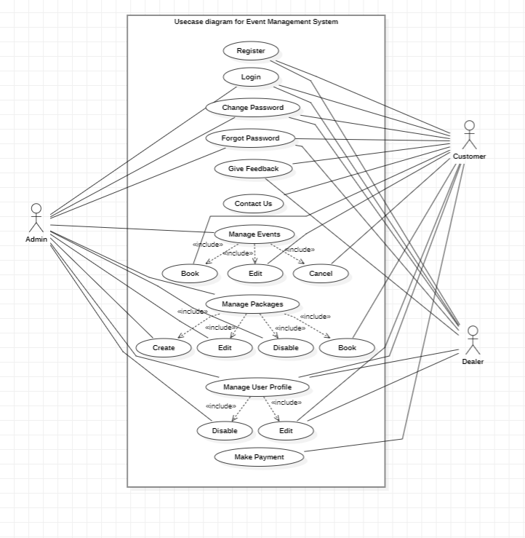

**5.2 Activity Diagrams:**

* Registration

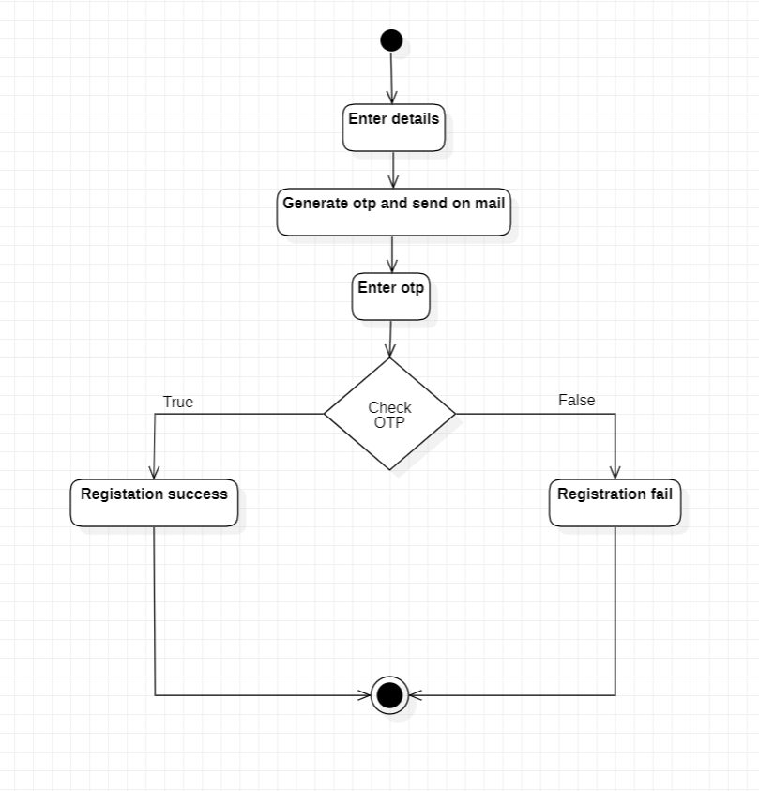

* Login

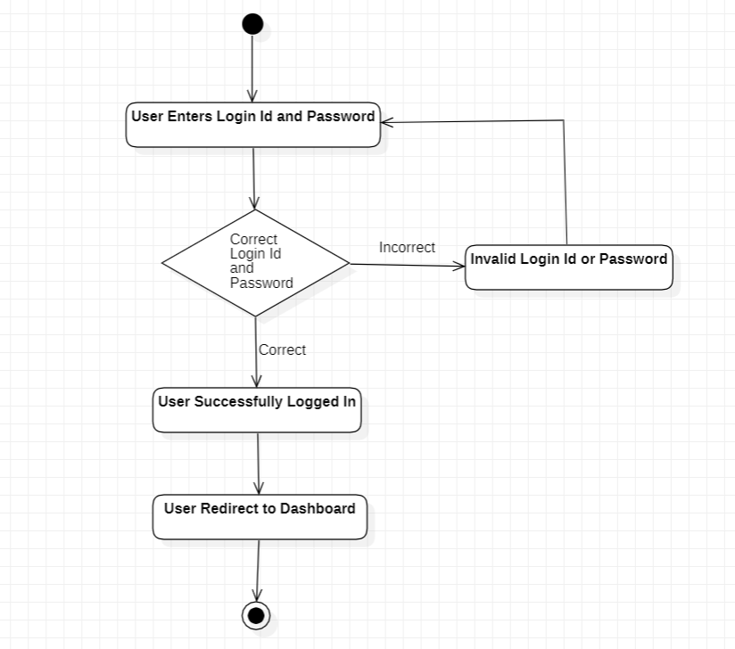

* Book Event

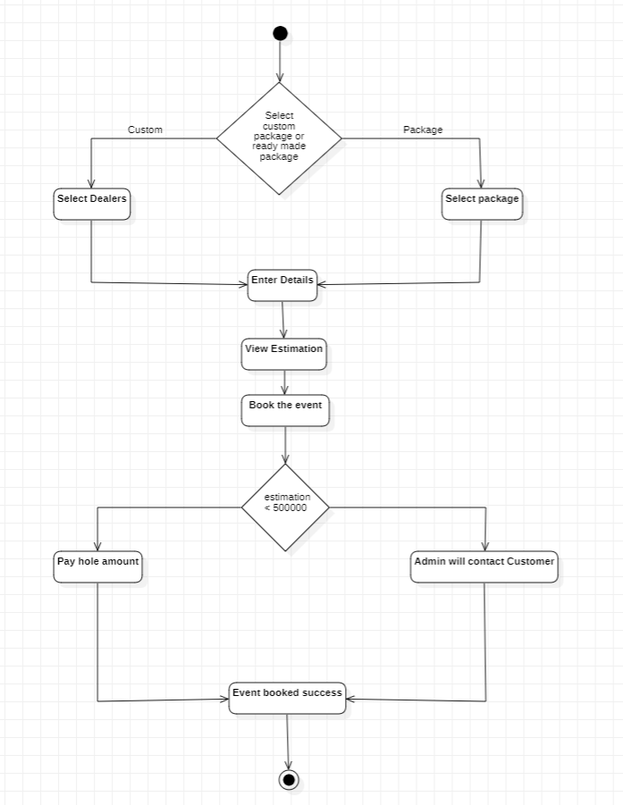

* Cancel Event

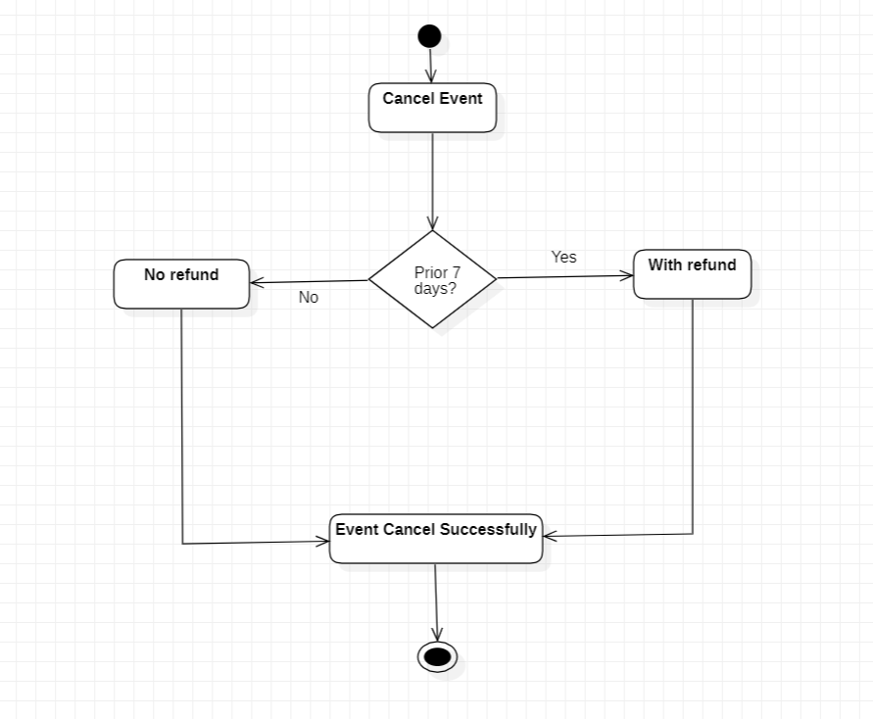

* Feedback

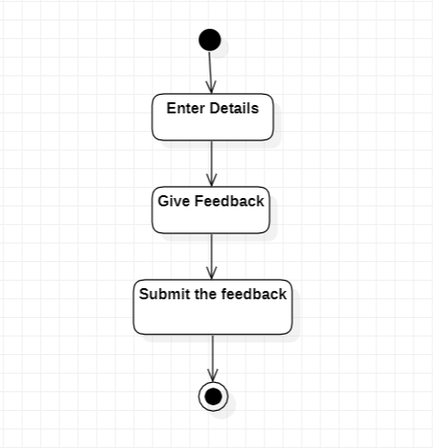

**5.3 Sequence Diagrams:**

* Registration

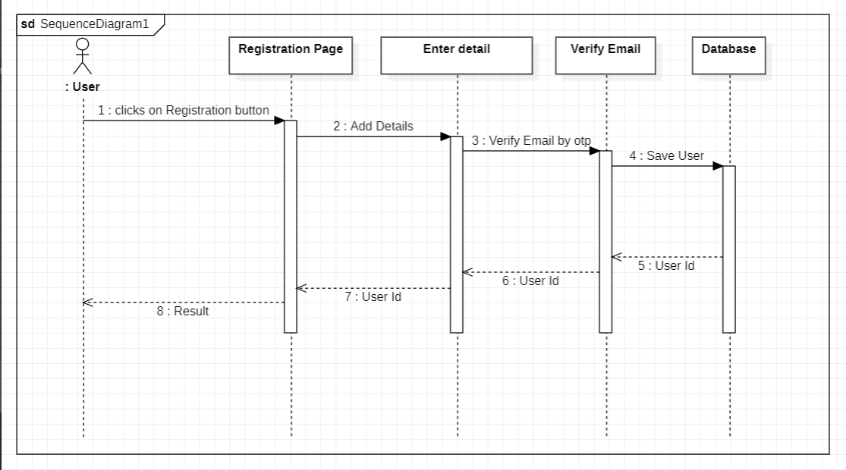

* Book Event

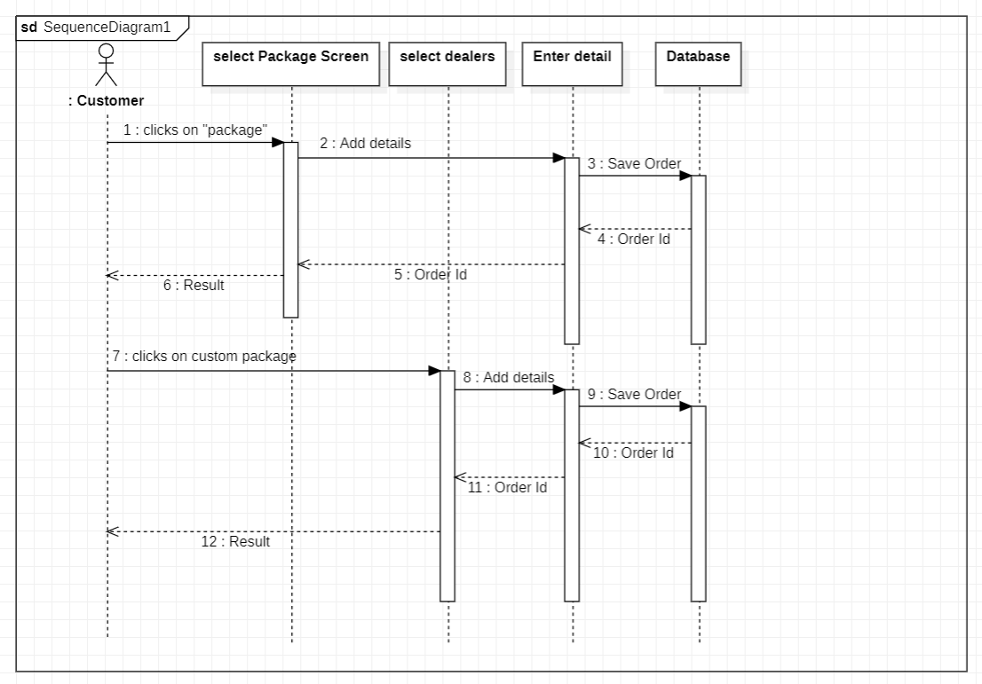

* Cancel Event

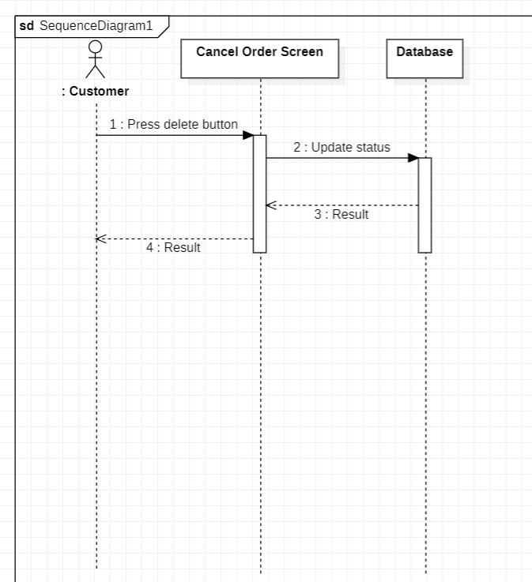

**System Implementation**

**6.1 Screenshots:**

* Home_Page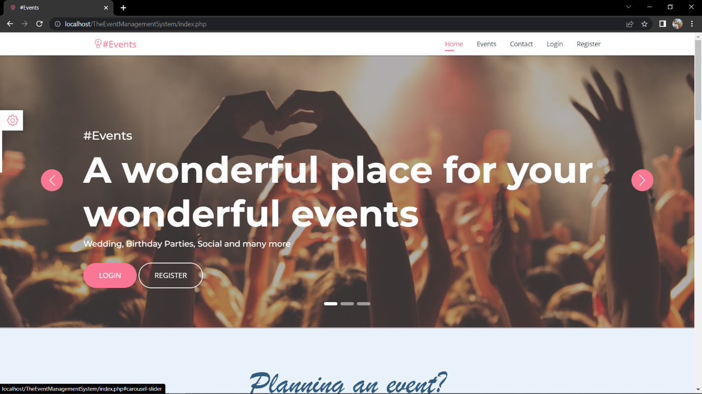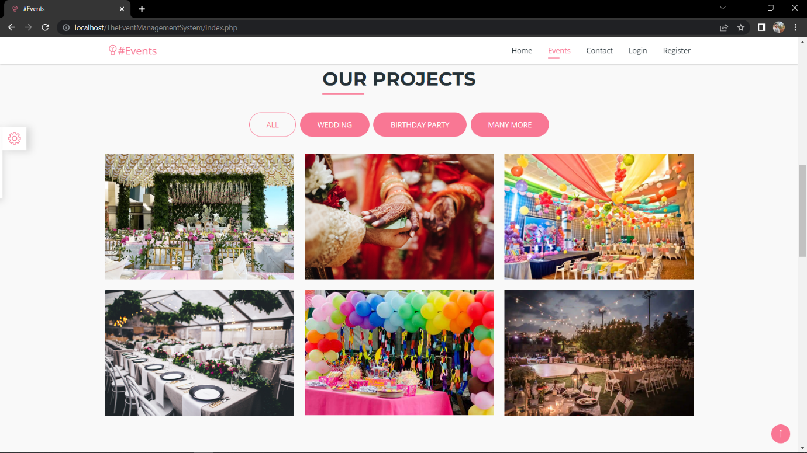
* Customer_Registration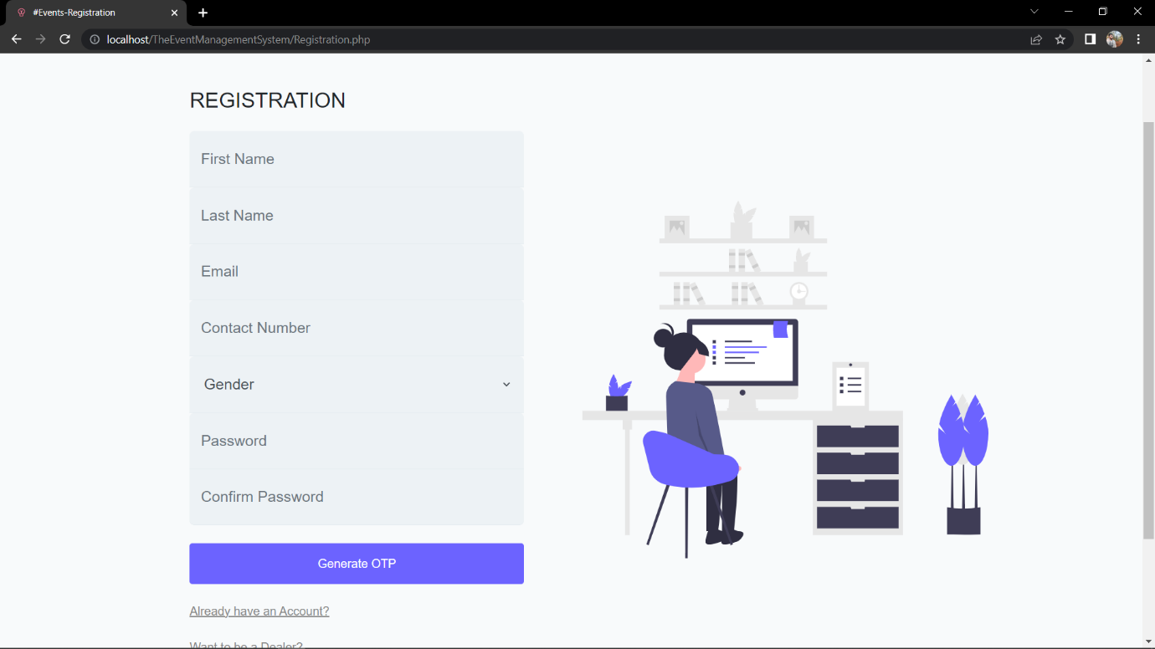
* Dealer_Registration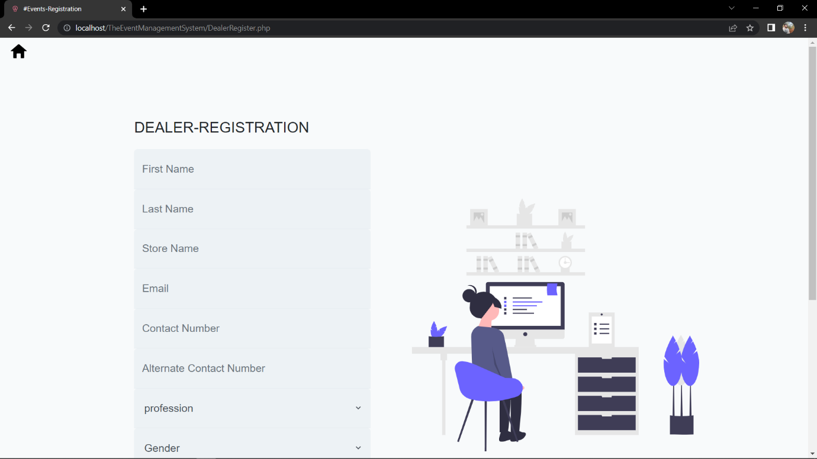
* Login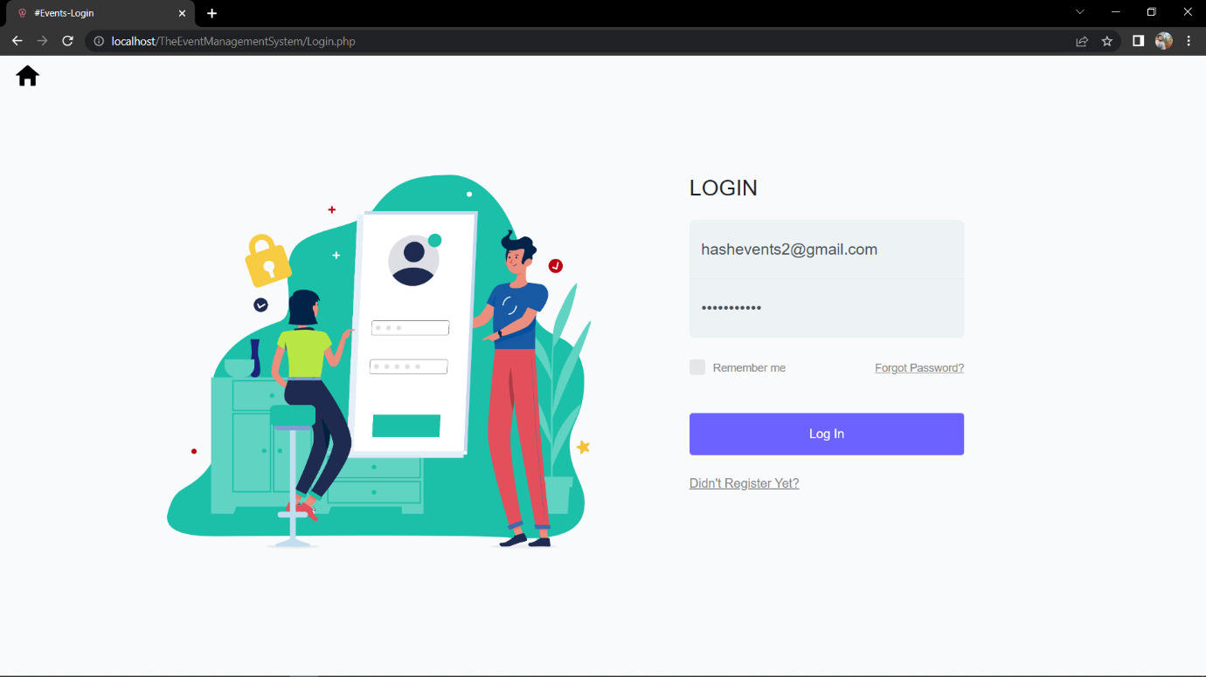
* Dealer_Dashboard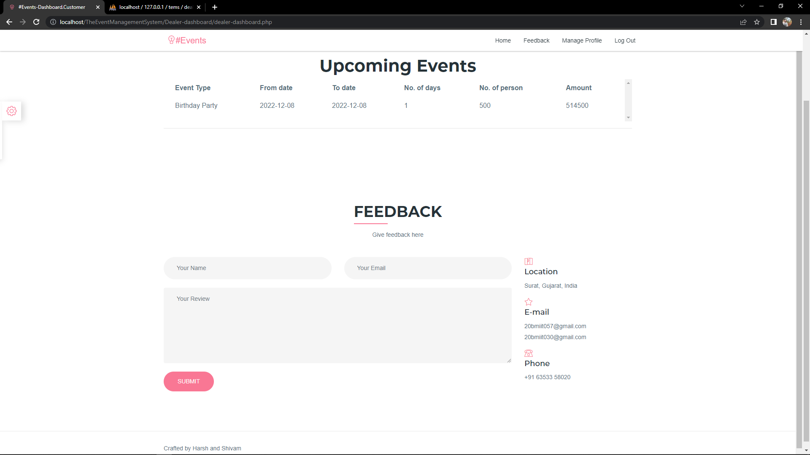
* Customer_Dashboard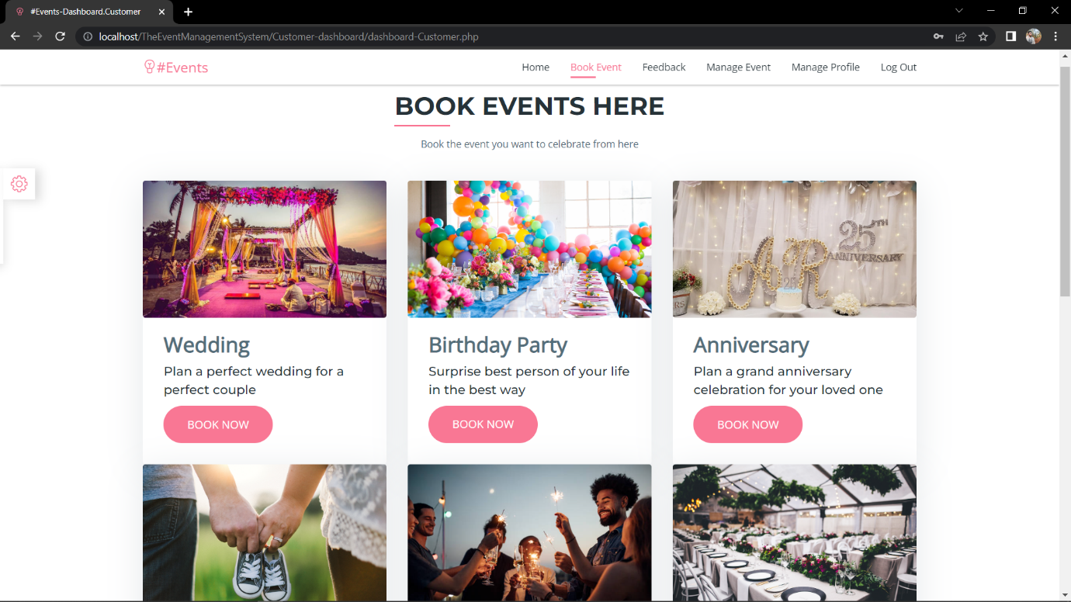 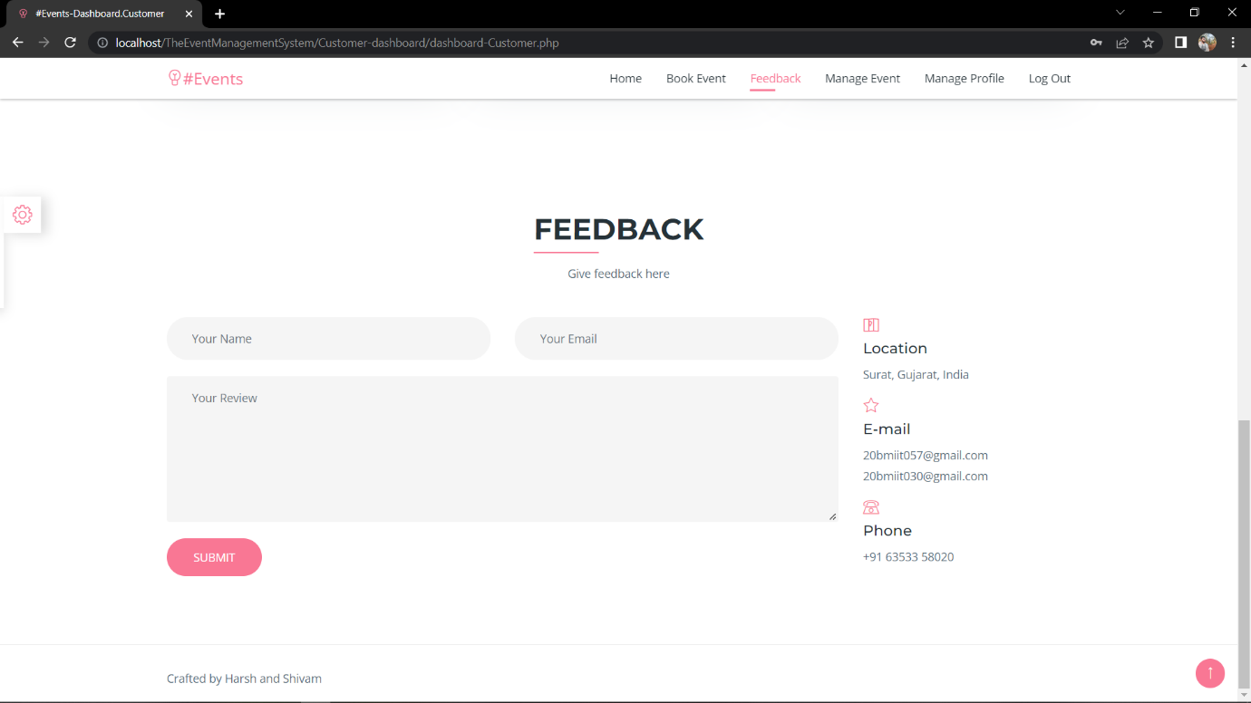
* Package_Selection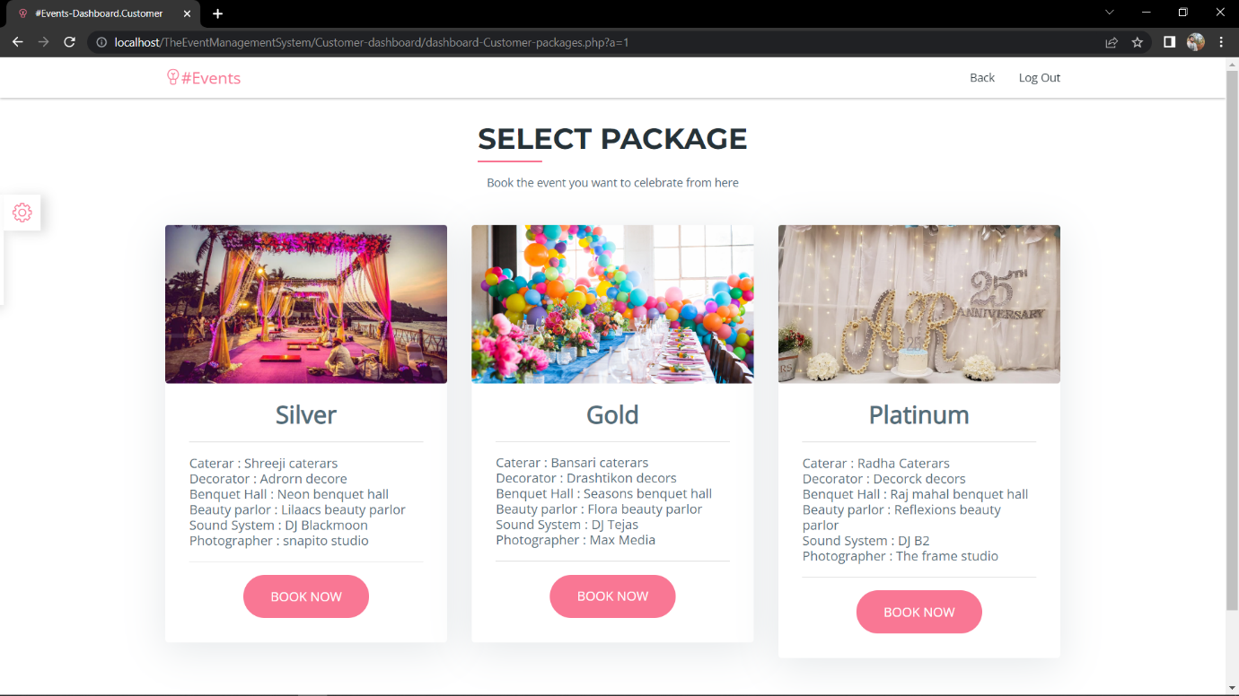
* Book_Event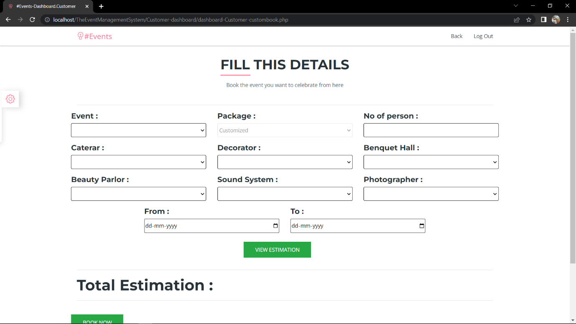
* Manage_Customer_Profile 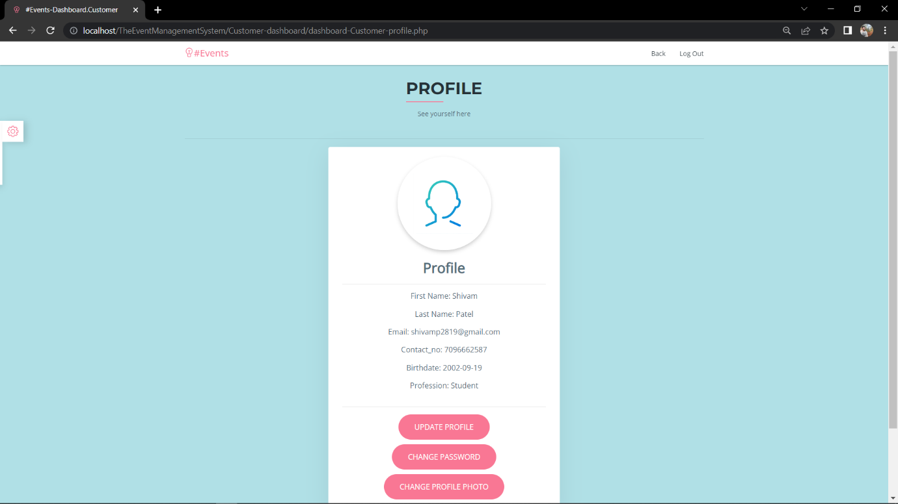
* Update_Customer_Profile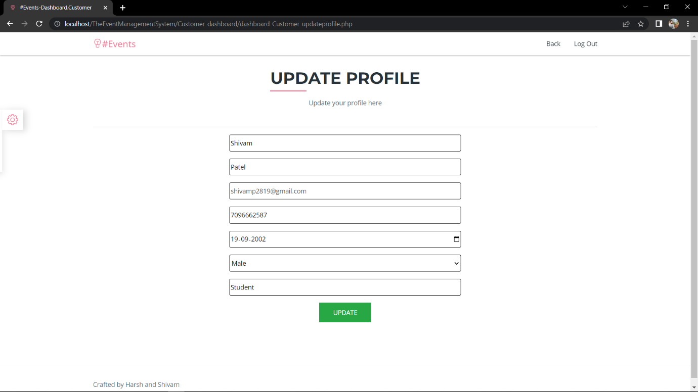
* Change_Password

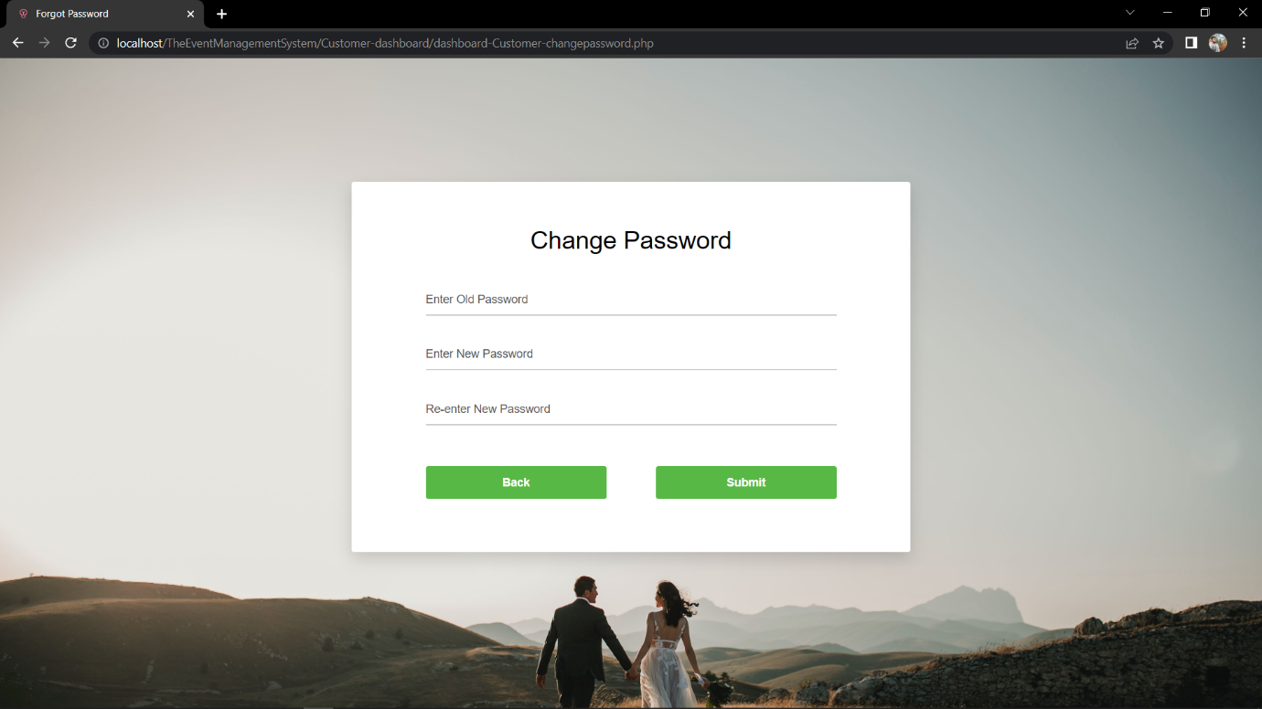

* Forgot_Password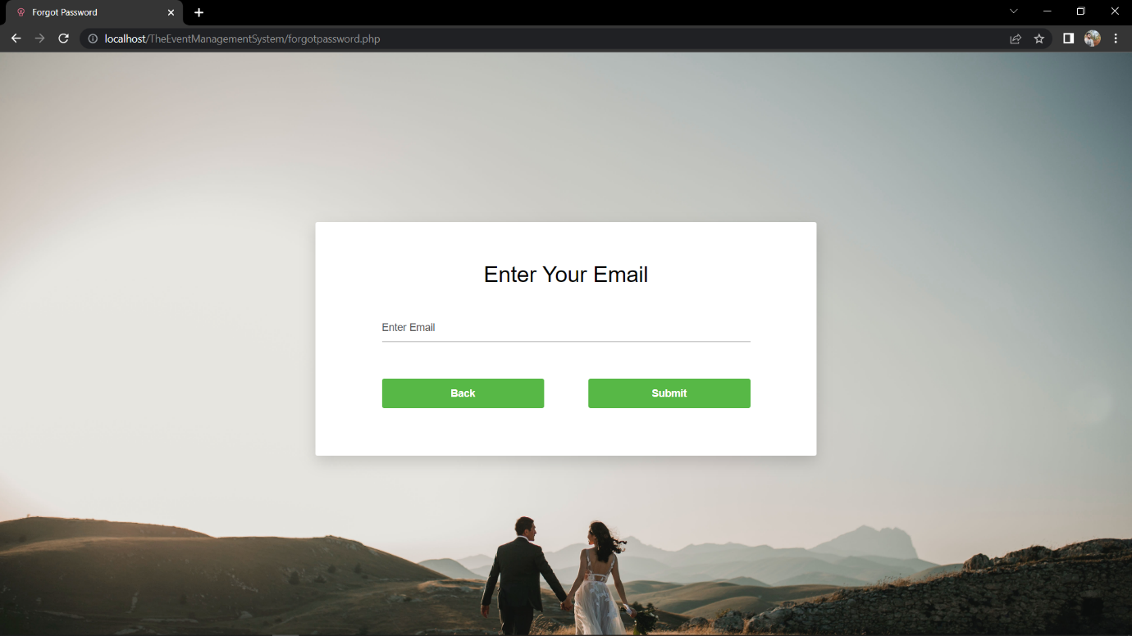 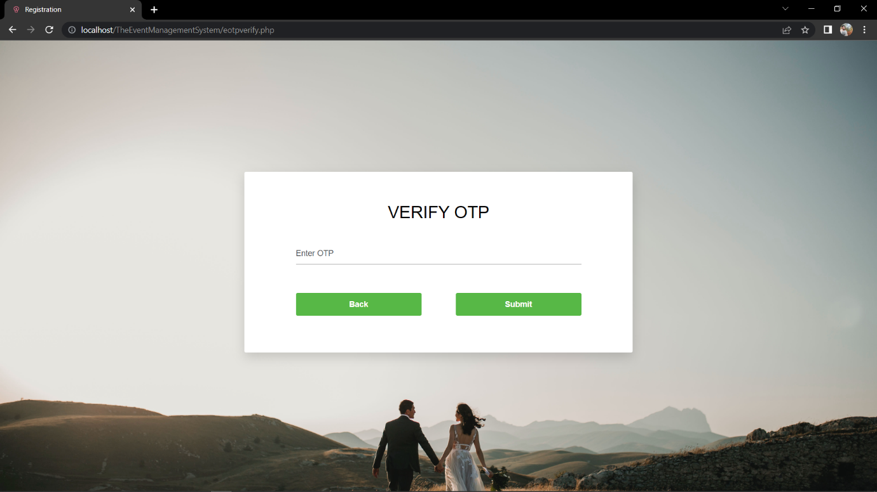
* Admin_Profile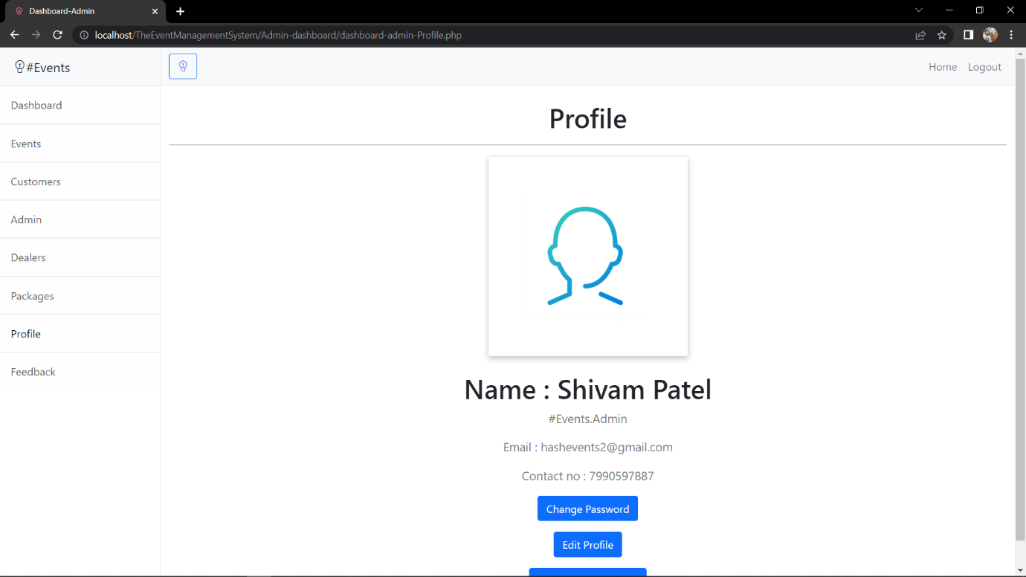
* Manage_Admins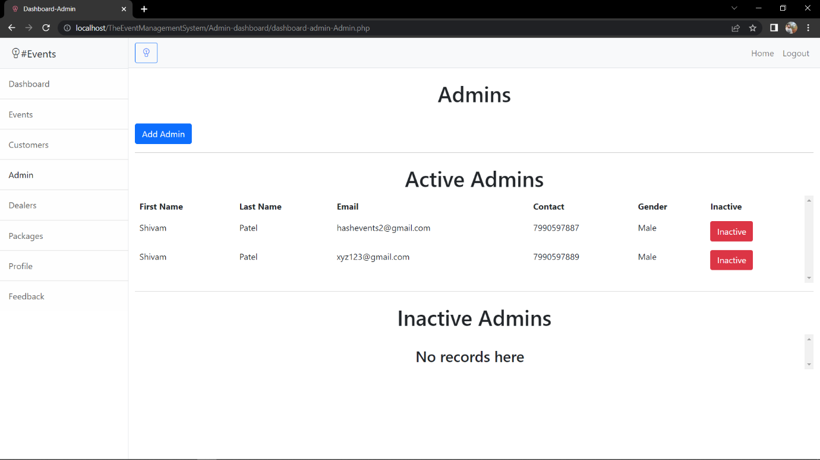
* View_Feedback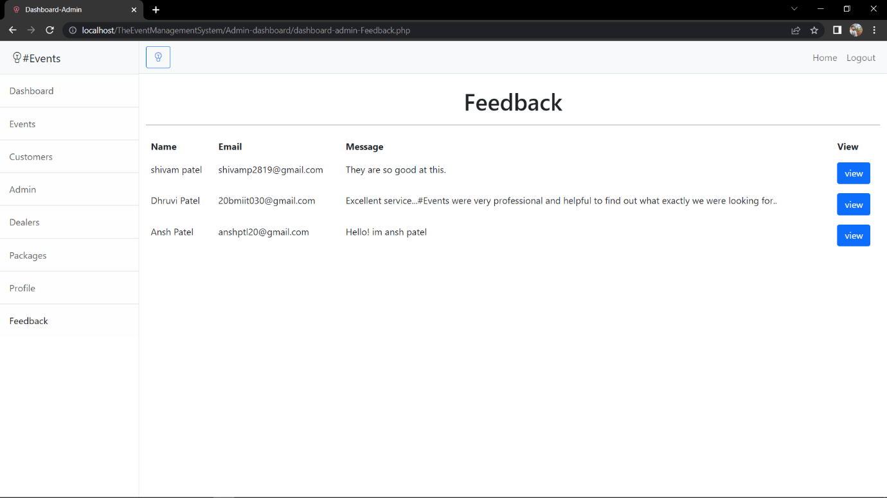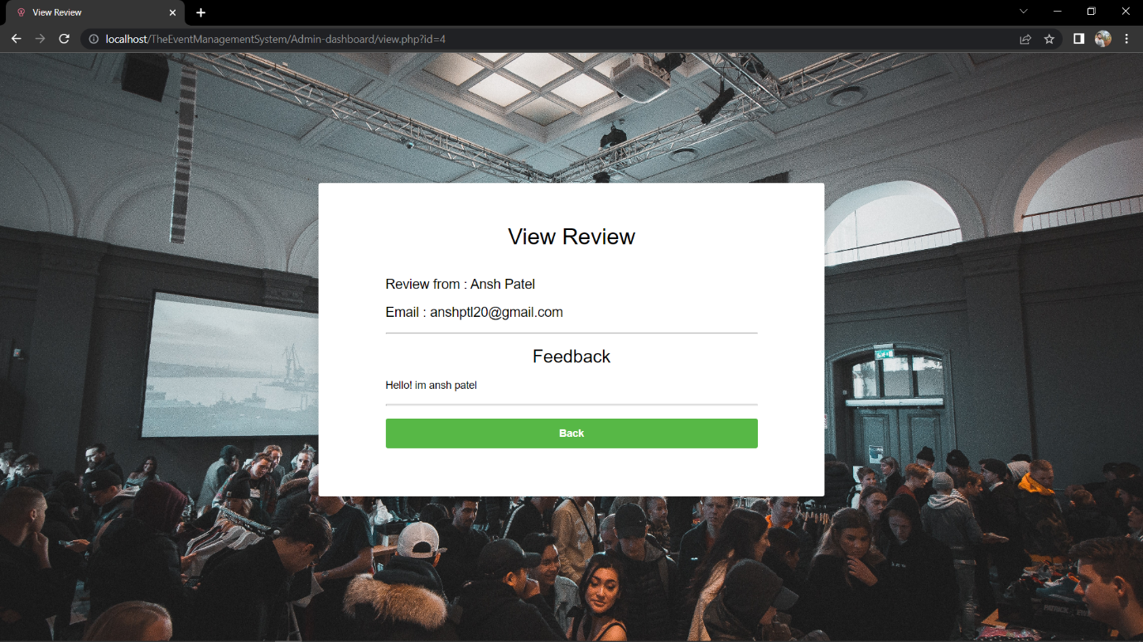
* Manage_Dealers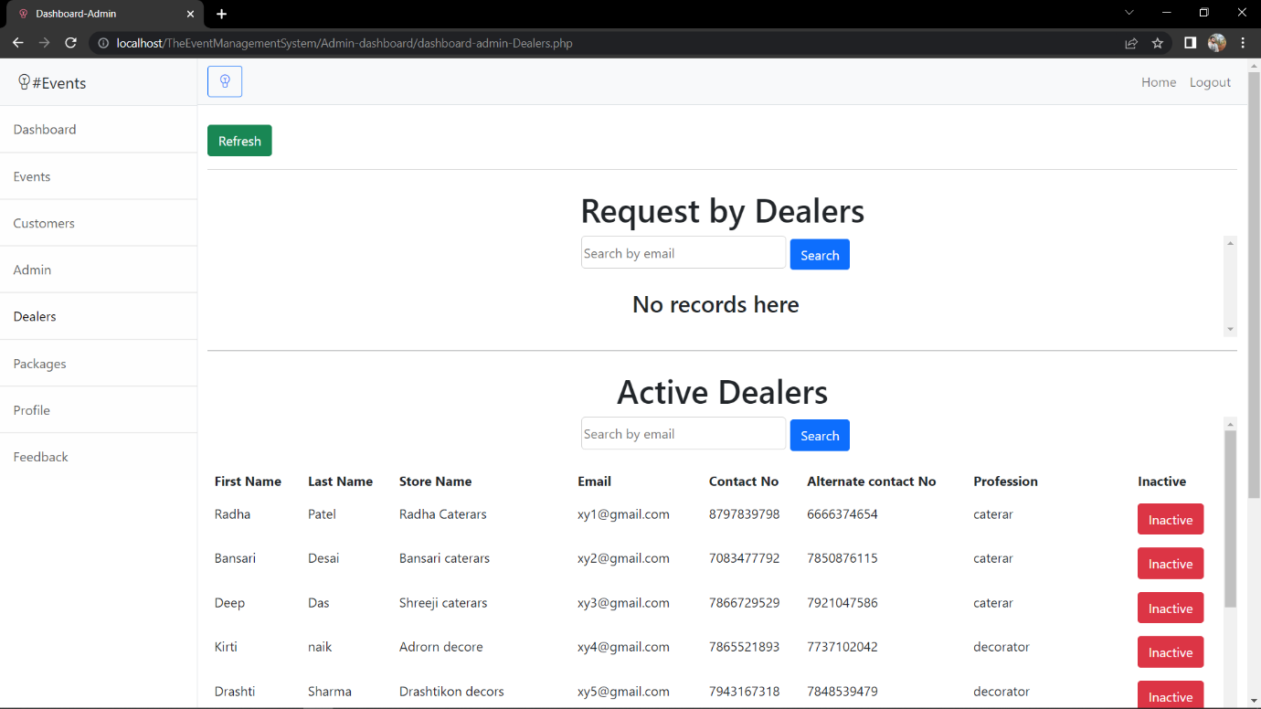
* Manage_Customers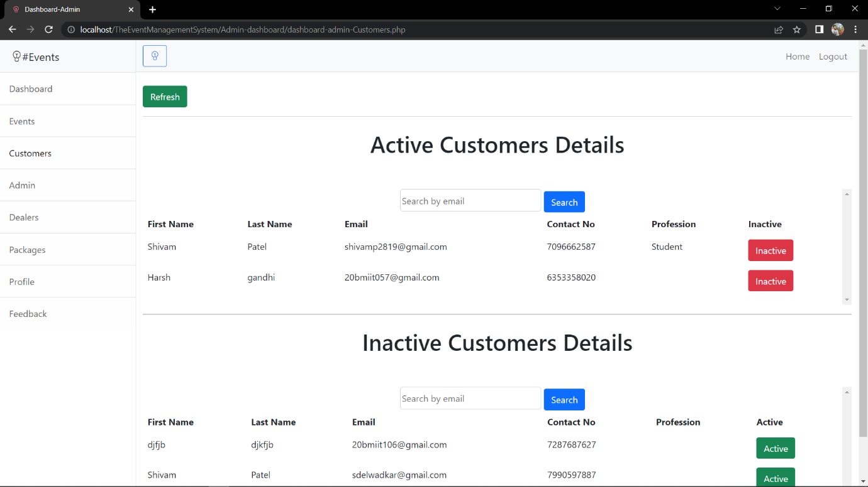
* Manage_Events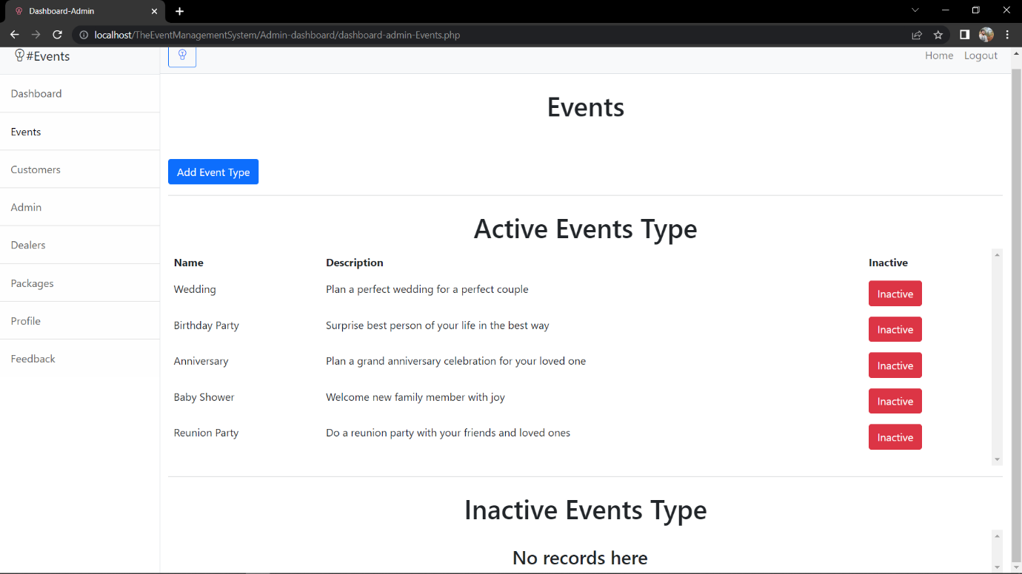
* Customer_Delete_Profile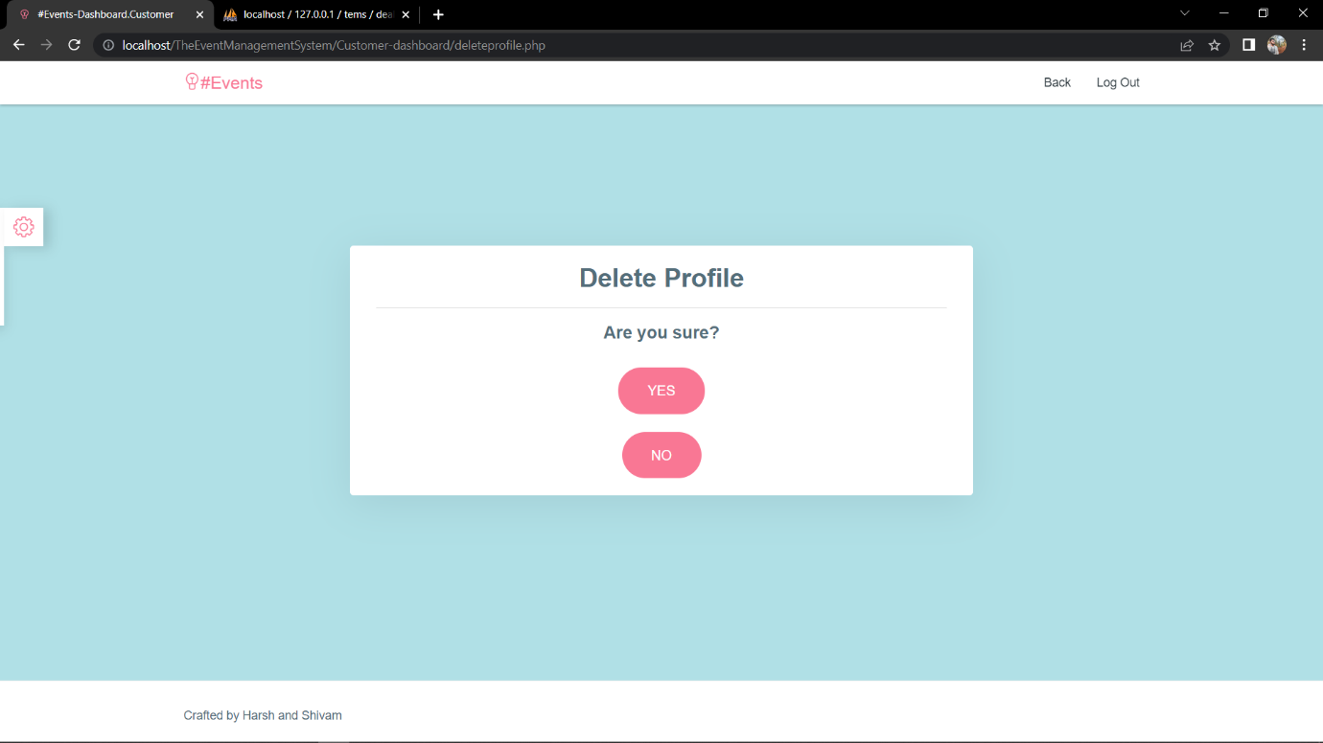

**Testing**

**7.1 Test Cases**

* Test Case for Registration

|  |  |  |  |  |  |  |  |  |  |  |
| --- | --- | --- | --- | --- | --- | --- | --- | --- | --- | --- |
| **Test Case Id** | **Description** | **Input 1** | **Input 2** | **Input 3** | **Input 4** | **Input 5** | **Input 6** | **Input 7** | **Output** | **Remarks** |
| **First Name** | **Last Name** | **Email** | **Contact Number** | **Gender** | **Password** | **Re-enter Password** |
| 1 | All field Blank | Blank | Blank | Blank | Blank | Blank | Blank | Blank | Enter details properly | All columns are blank |
| 2 | Password less than 8 character | Valid | Valid | Valid | Valid | Valid | Invalid | Invalid | Password should be 8 or more character long | Invalid password form |
| 3 | Password doesn’t match | Valid | Valid | Valid | Valid | Valid | Invalid | Valid | Password Doesn’t match | Invalid password form |
| 4 | Invalid Email | Valid | Valid | Invalid | Valid | Valid | Valid | Valid | Enter valid email | Invalid email input |
| 5 | Invalid contact number | Valid | Valid | Valid | Invalid | Valid | Valid | Valid | Enter valid  Contact  Number | Invalid contact number |
| 6 | Email already exists | Valid | Valid | Valid | Valid | Valid | Valid | Valid | User already exist | Email already exists |

* Test Case for Login

|  |  |  |  |  |  |  |
| --- | --- | --- | --- | --- | --- | --- |
| **Test case ID** | **Description** | **Input 1** | **Input 2** | **Input 3** | **Expected output** | **Remarks** |
| **Email** | **Password** | **Remember me** |
| TC1 | User Authenticated | Valid | Valid | Valid | User Logged in Successfully | Login credentials will be stored in cookies |
| TC2 | Email is blank | Invalid | Valid | Valid | Invalid Email | Invalid Email input |
| TC3 | Password is blank | Valid | Invalid | Valid | Invalid Password | Invalid Password input |
| TC4 | Remember me is blank | Valid | Valid | Invalid | User Logged in Successfully | Login credentials won’t be stored in cookies |

* Test Case for Change Password

|  |  |  |  |  |  |  |
| --- | --- | --- | --- | --- | --- | --- |
| **Test case ID** | **Description** | **Input 1** | **Input 2** | **Input 3** | **Expected output** | **Remarks** |
| **Old Password** | **New Password** | **Confirm Password** |
| TC1 | Change Password | Valid | Valid | Valid | User password changed Successfully | - |
| TC2 | Old password is blank | Invalid | Valid | Valid | Invalid old password | Invalid old password input |
| TC3 | New Password is blank | Valid | Invalid | Valid | Invalid new password | Invalid new password input |
| TC3 | Confirm Password is blank | Valid | Valid | Invalid | Invalid confirm password | Invalid confirm password input |
| TC4 | Password doesn’t match | Valid | Valid | Valid | Password won’t change | Old and new password doesn’t match |

**Future Enhancement**

* The system may undergo modifications or improvements to allow for use in multiple cities.

**Conclusion**

* Customers will be able to book events via this method. The system will offer several package categories from which users can book their preferred events according to their budgets.

**Bibliography**

* PHP and MySQL Hugh F. Williams. O’Really.
* Yogesh Singh, R. Malhotra, Object Oriented Software Engineering, PHI.